# **How to set up monitoring**

Step 1: Set Up Helm (If Not Installed)

curl -fsSL -o get_helm.sh <https://raw.githubusercontent.com/helm/helm/main/scripts/get-helm-3>

chmod 700 get_helm.sh

./get_helm.sh

helm version

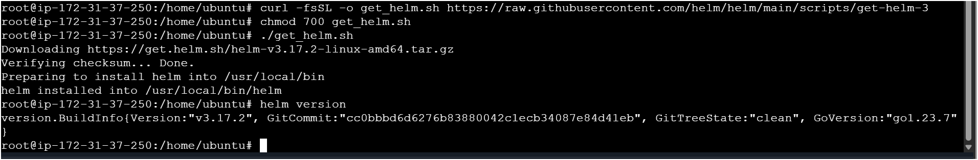

Step 2: Add the Prometheus & Grafana Helm Repository

helm repo add prometheus-community https://prometheus-community.github.io/helm-charts

helm repo update

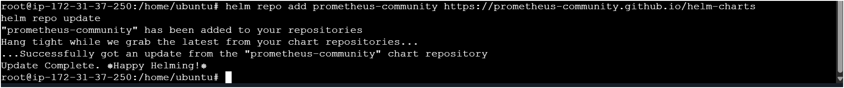

Step 3: Install Prometheus using Helm

kubectl create namespace monitoring

helm install prometheus prometheus-community/kube-prometheus-stack --namespace monitoring

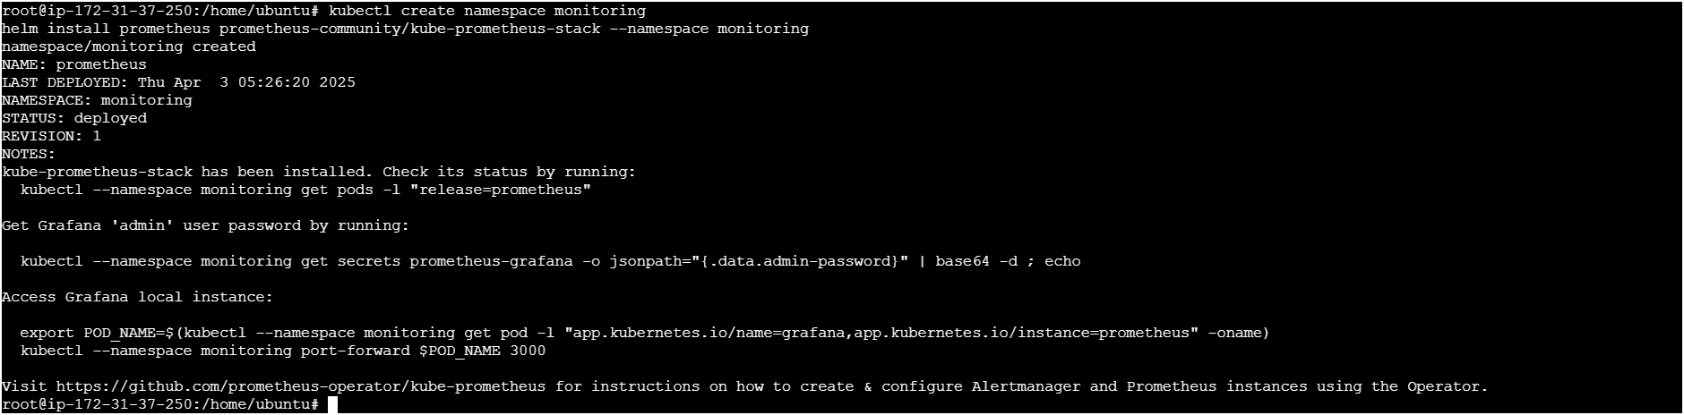

Step 4: Expose Grafana via a LoadBalancer

kubectl patch svc prometheus-grafana -n monitoring -p '{"spec": {"type": "LoadBalancer"}}'



Step 5: Get the Grafana LoadBalancer URL

kubectl get svc -n monitoring prometheus-grafana



Expose Prometheus as a Load Balancer

Patch the Prometheus Service

kubectl patch svc prometheus-kube-prometheus-prometheus -n monitoring -p '{"spec": {"type": "LoadBalancer"}}'

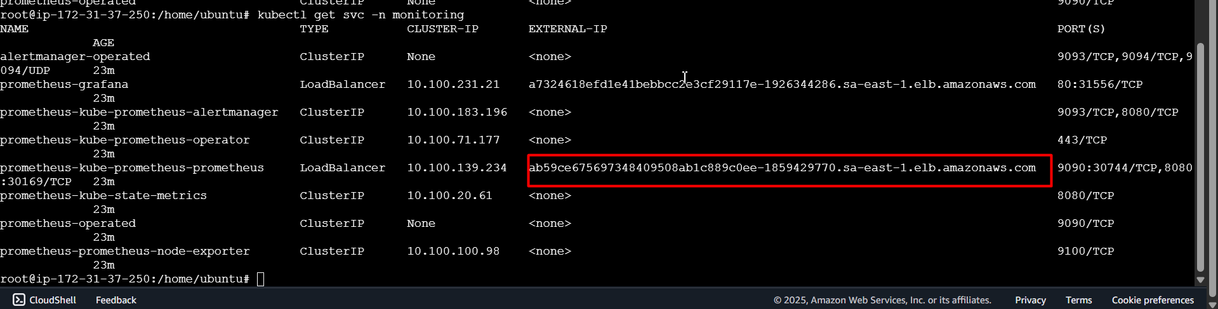

Access Prometheus on web browser

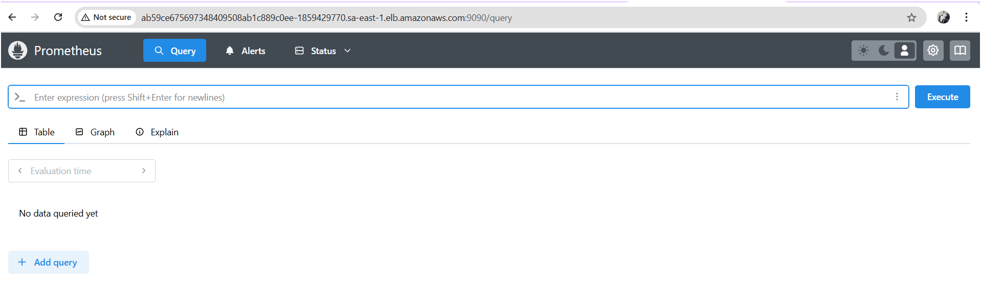

Step 6: Access Grafana

Open **http://<EXTERNAL-IP>:80** in your browser.

**Default Login Credentials:**

* **Username:** admin
* **Password:** prom-operator (Default, change after login)

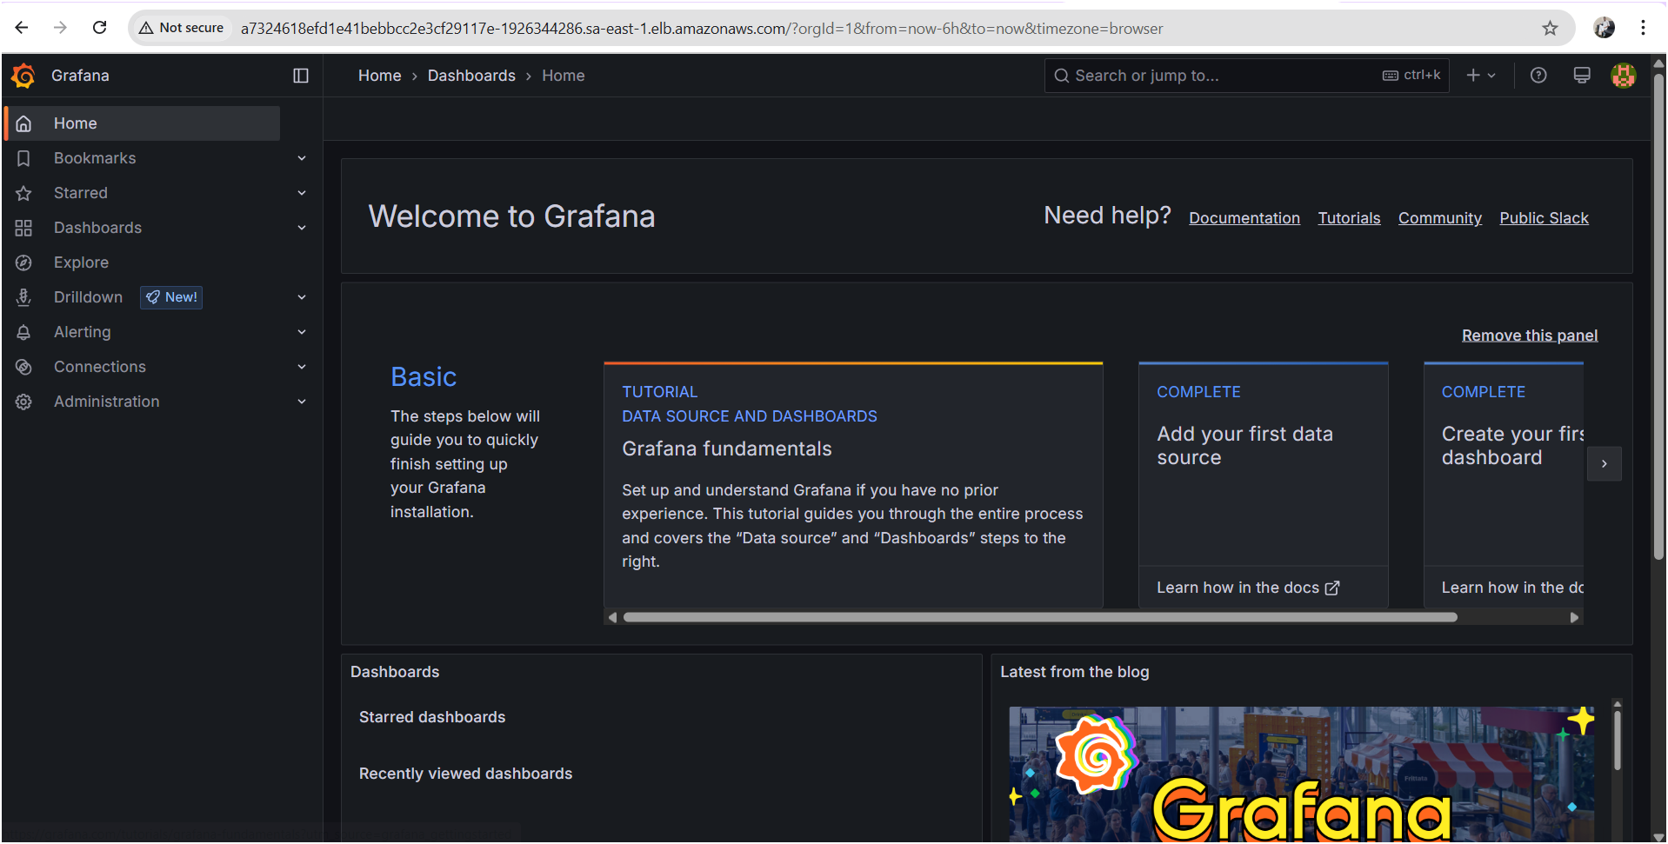

Step 7: Configure Dashboards in Grafana

1. **Log in to Grafana**.
2. Go to **Configuration → Data Sources**.

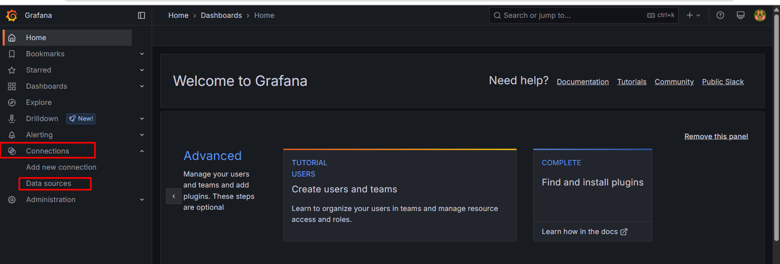

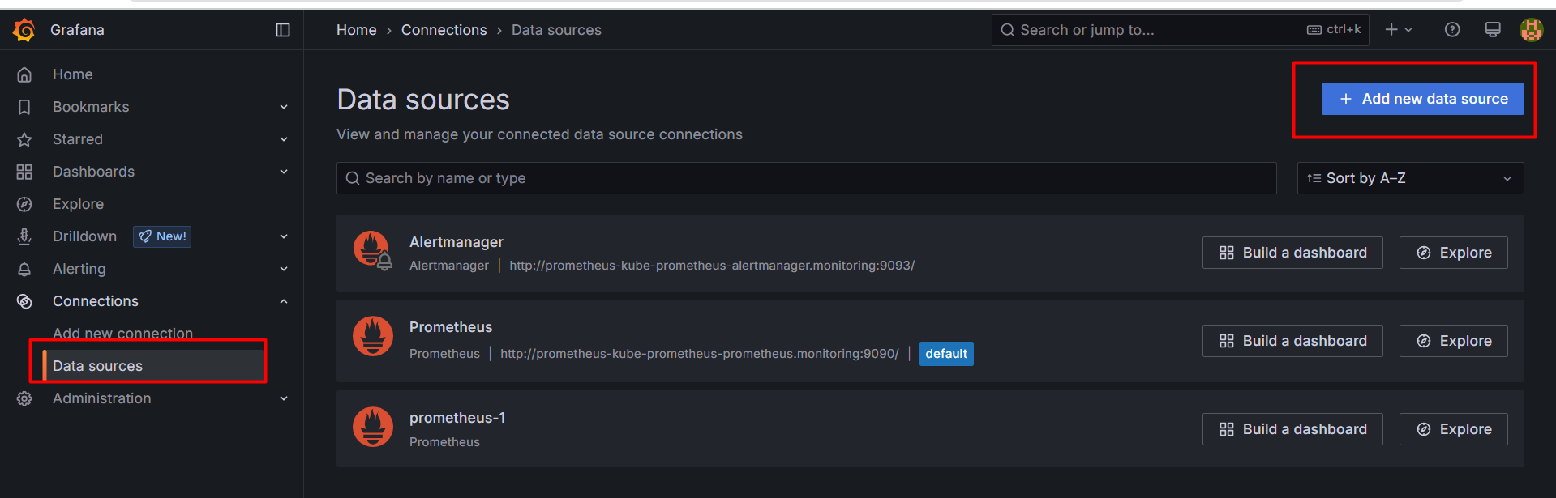

Search for Prometheus and click on

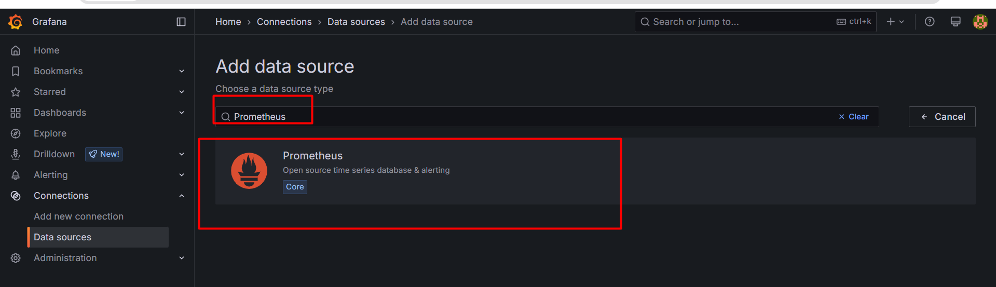

1. Add **Prometheus** as a data source:
   * **URL:** <http://ab59ce675697348409508ab1c889c0ee-1859429770.sa-east-1.elb.amazonaws.com:9090>

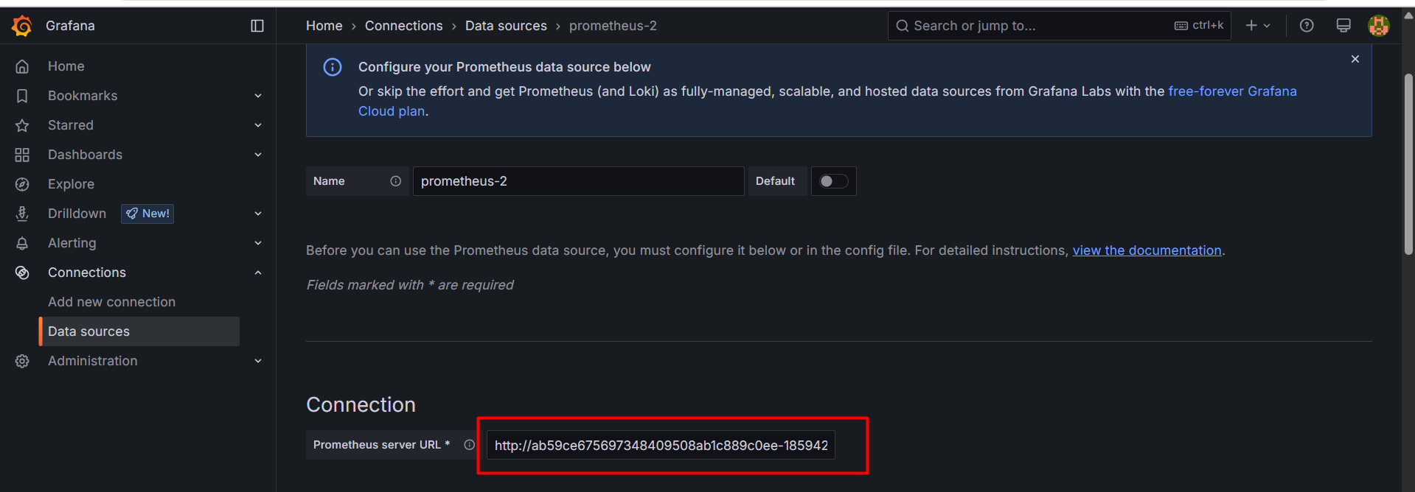

* + Click **Save & Test**.

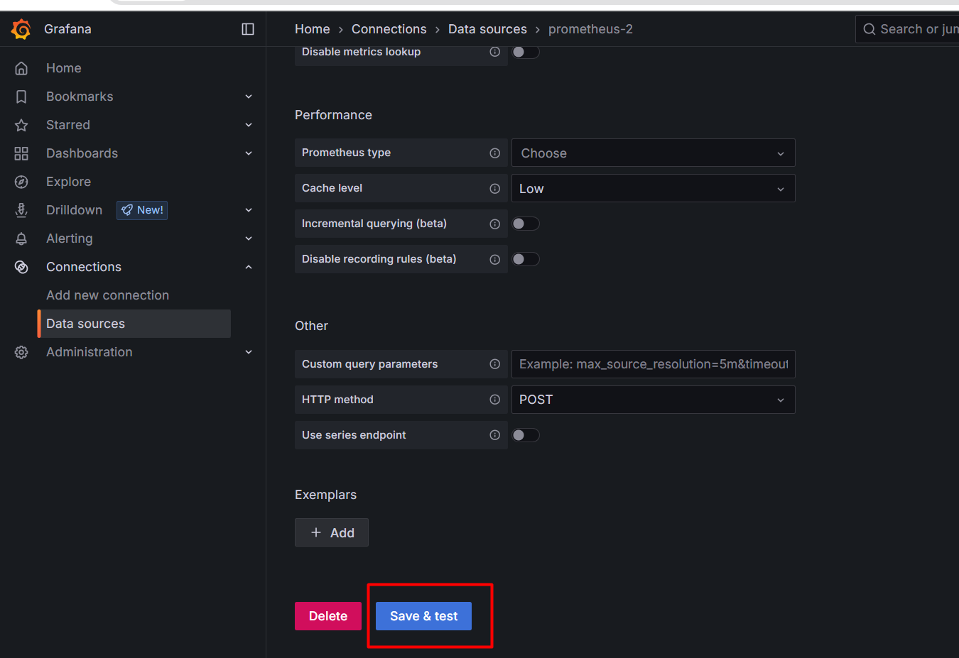

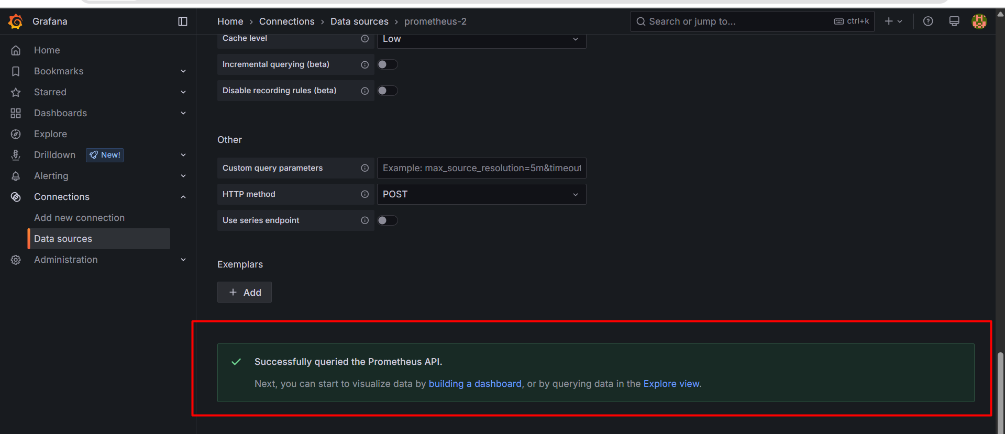

1. Go to **Dashboards → Import**, and enter **ID: 315** (Kubernetes Metrics Dashboard).

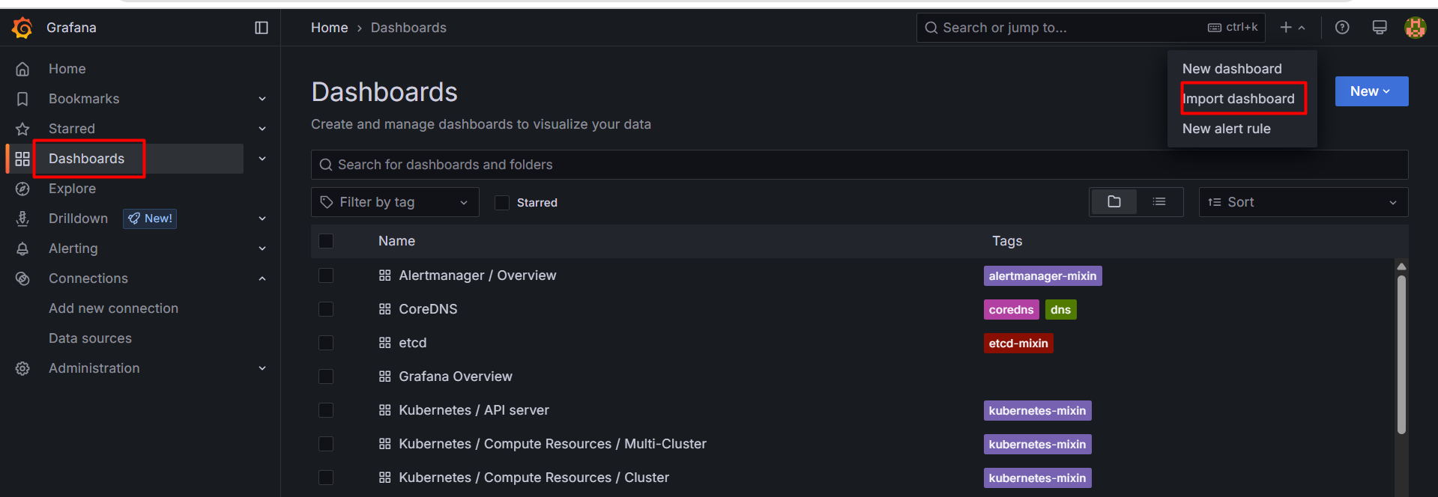

Provide k8s metrics dashboard id and click on load

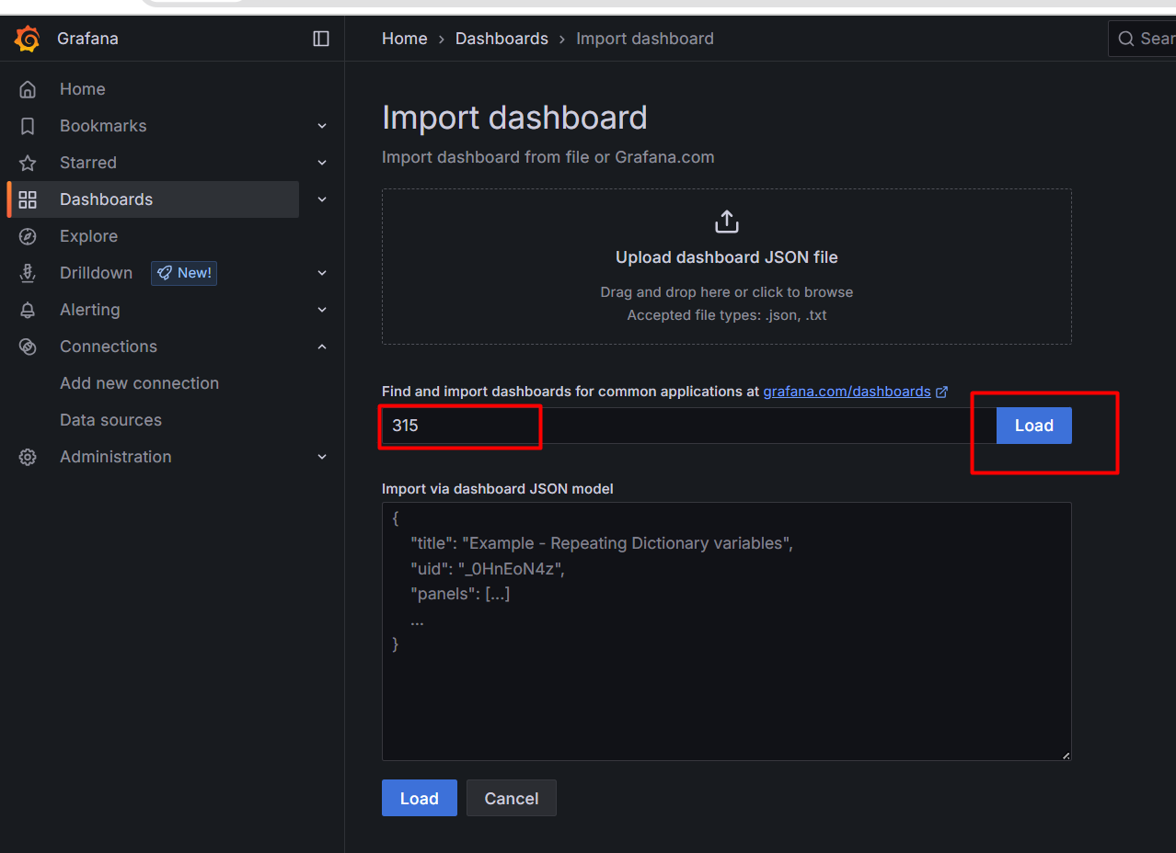

You will get page like this

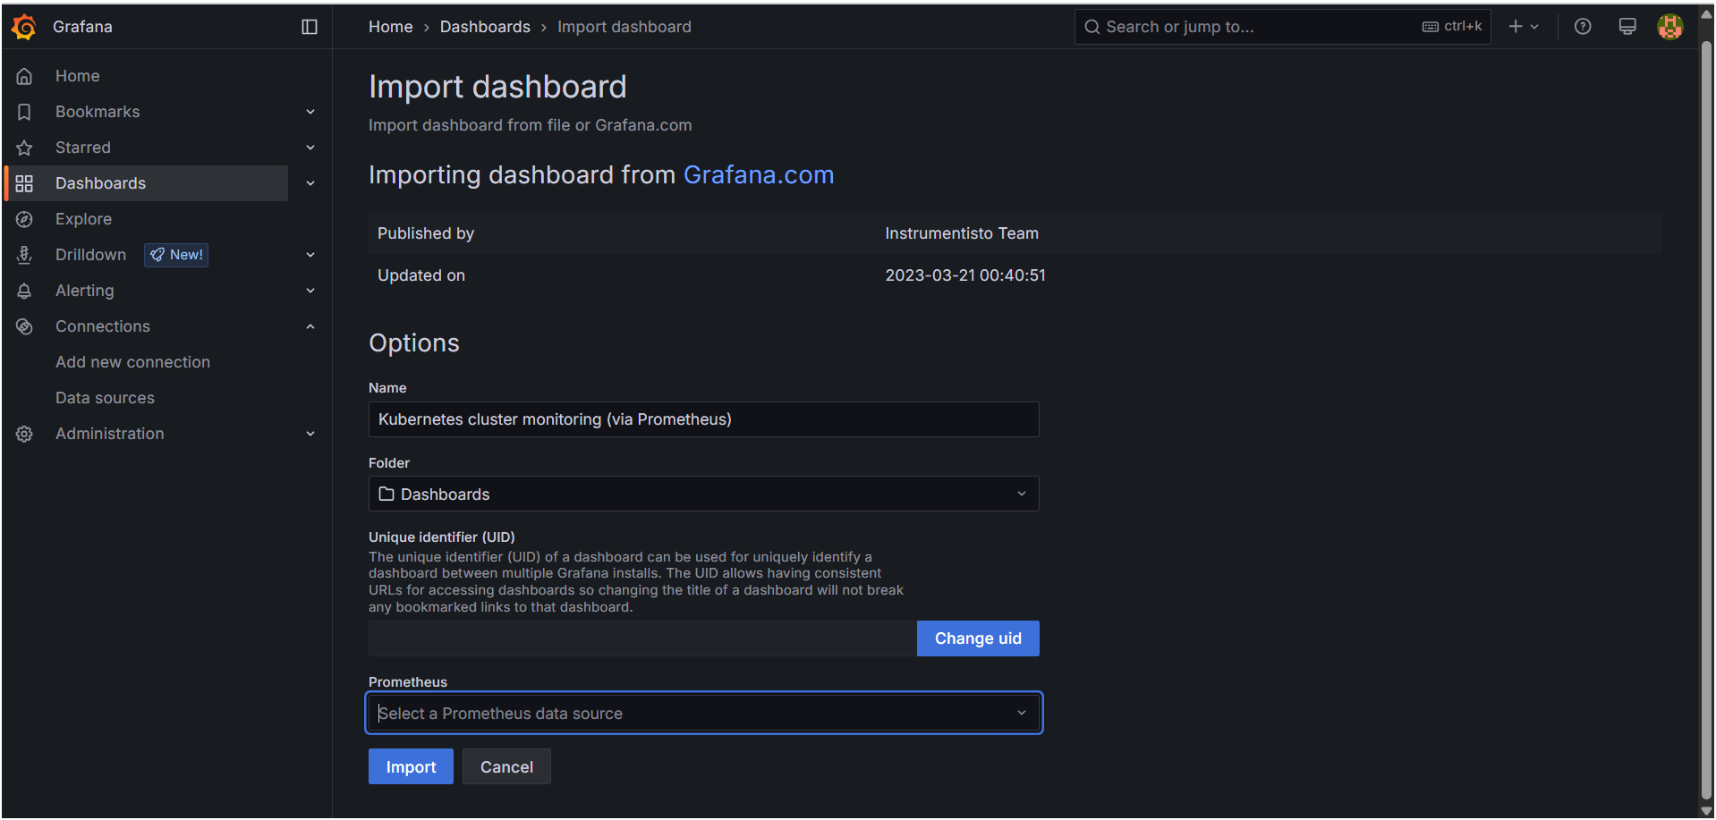

Next you need to select your Prometheus dashboard as shown below pic

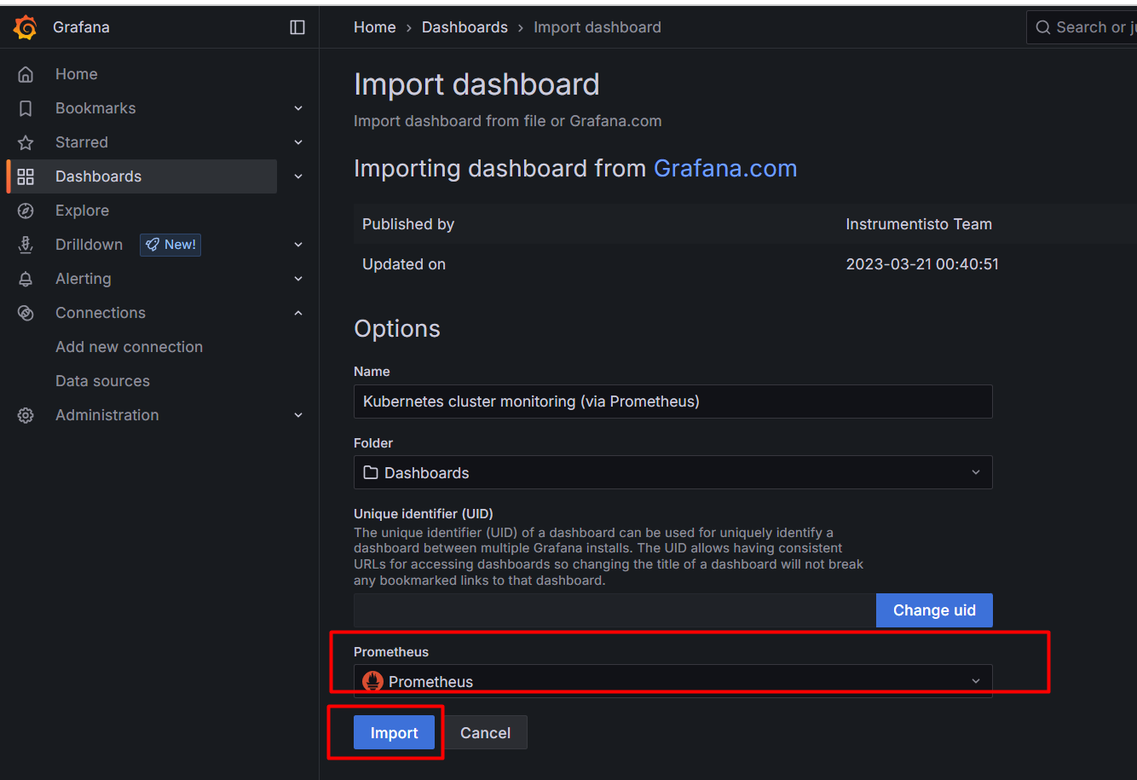

Our Grafana dashboard is ready

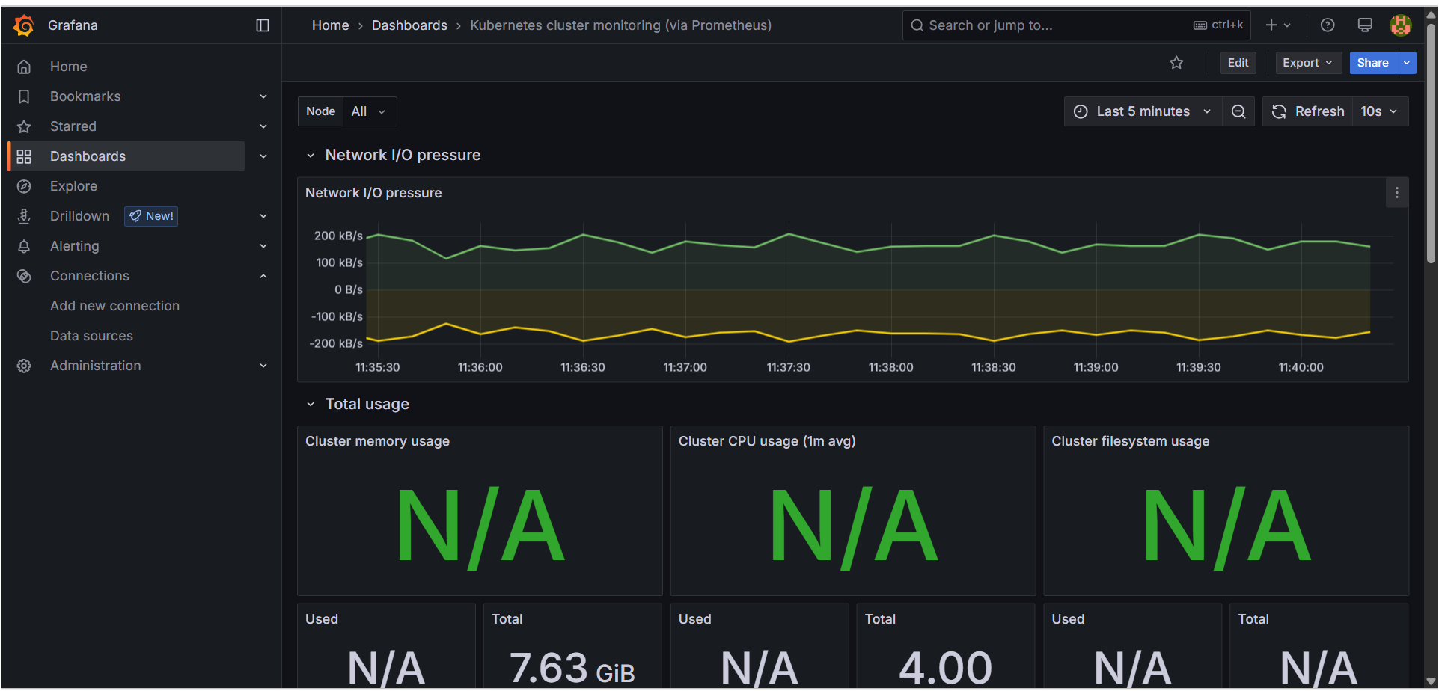

Now go to Prometheus and get targets

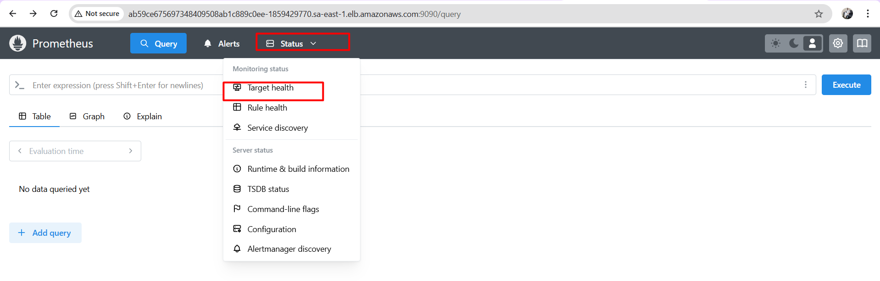

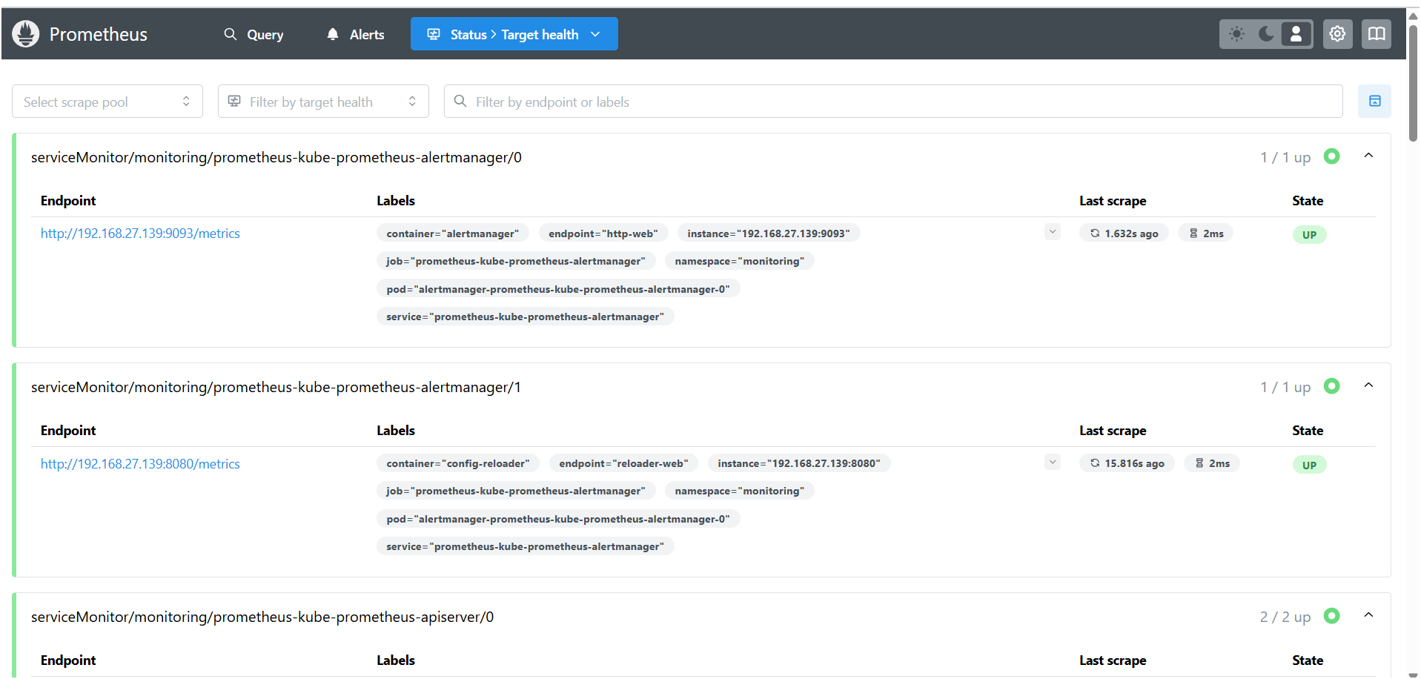

# Installation commands

helm repo add prometheus-community https://prometheus-community.github.io/helm-charts

helm repo add grafana https://grafana.github.io/helm-charts

helm repo update

helm install prometheus prometheus-community/prometheus --namespace monitoring --create-namespace

helm install grafana grafana/grafana --namespace monitoring

THE END